How to Search Online for Objects in the Natural History Society of Northumbria Archive and Collections Database

Go to
http://collectionssearchtwmuseums.org.uk/#browse=enarratives.17433&venue=hancock

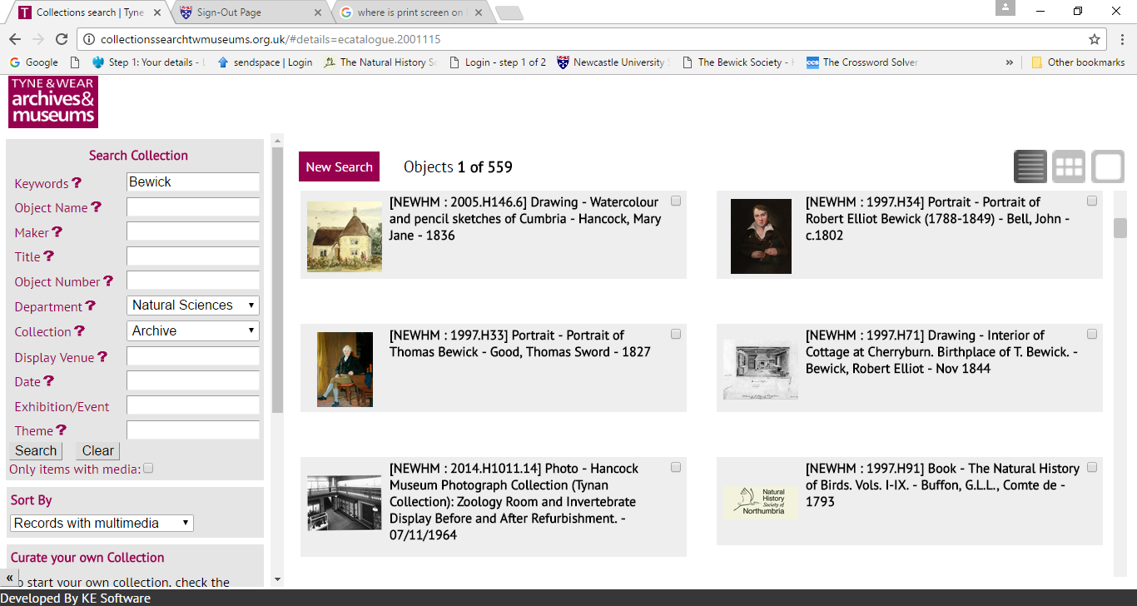

The collection database currently operating on the Great North Museum:Hancock& the NHSN website contains records from the Great North Museum:Hancock and all of the other Museums under Tyne & Wear Archives & Museum’s (TWAM) jurisdiction.

To access only GNM:H collection records and archives you have to apply search parameters from the drop down menus.

Department: Apply ‘Natural Sciences’ this will restrict your search to items in the GNM:Hancock, Sunderland Museum and Discovery Museum.

Collection: This dropdown gives you 6 options ‘Archive’ will bring up only the NHSN Archive Collection.
You can also choose ‘Botany’, ‘Earth Sciences’ (Geology), ‘Invertebrate Zoology’, ‘Vertebrate Zoology’ & ‘Palaeobiology’. This will bring up records from all the TWAM curated museums in the North East but most of the NHSN museum collections can be identified by the reference ‘NEWHM’

