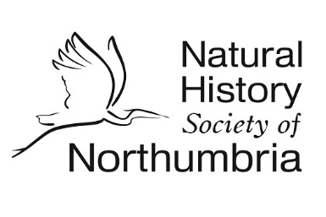
Gosforth Nature Reserve
Education Visit Booking Form

If you have some idea of what you would like to do on your visit, complete and return this form to nhsn@ncl.ac.uk. If you would like to discuss a more tailored visit, or if you have any questions, please do not hesitate to get in touch at the same address.
Name of school/group
Name & Email address of teacher/group leader
No. of children/group members
Ages of group members
Reason for visit/preferred activities
Your preferred dates of visit
Your preferred time of visit, including anticipated arrival and departure time, and if you would like to stay for lunch
Any special needs/requirements
Mobile number of teacher/group leader in case of cancellation due to bad weather

Please note that:
- The school/group leader is responsible for supervising children/group members and providing first aid cover during the visit. There should be a ratio of 1:10 adults to children.
- It is not necessary that leaders and supervisors be knowledgeable about nature, as NHSN Education Ranger volunteers will provide natural history and site expertise. However, it is necessary that leaders and supervisors know and understand the children, and any needs they may have.
- We also stress that it is your responsibility to ensure children are suitably dressed for the weather, and we particularly recommend warm, waterproof clothing, and appropriate shoes for unpaved surfaces.

A sample risk assessment can be found on our website here: https://www.nhsn.org.uk/education-at-gnr/

