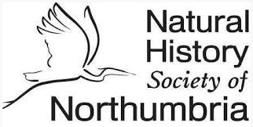

Dickinson Memorial Fund: Application for Grant

Name
Membership No.
Group – you are applying on behalf of
Project name
Project aim | Please describe your project in no more than 300 words
Project cost | £
Amount applied for | £
How will your project benefit wildlife in North East England? | Max 150 words
How will your project connect to people in North East England? | Max 150 words
Will you be able to supply NHSN with text images to share the learning / impact of your project? | Yes  No  Comments
Project timetable | Start date  Completion date
Date of application

Please submit your application to Clare Freeman, Director at nhsn.director@newcastle.ac.uk by 28 February 2023

