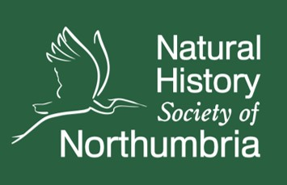
Student Naturalist Placements

Information Pack
January 2026

About NHSN
Established in 1829, the Natural History Society of Northumbria is one of the longest-running natural history societies. Our vision is for more people to enjoy, understand and care for North East nature. We aim to inspire wonder and collective action in all aspects of North East natural history through communications, events, lifelong learning, and regional citizen science. At the heart of our delivery is a huge community of passionate volunteers, members, and supporters.
Supported by a growing community of volunteers, we have managed Gosforth Nature Reserve in Newcastle upon Tyne since 1929. One of the most important wildlife sites in Newcastle, the reserve is a rich educational resource. In January 2022, the new Field Station opens its doors to provide a practical and inspiring space for visitors and groups.
Our office is based at the Great North Museum: Hancock. The museum and natural history collections are owned by NHSN and leased to Newcastle University. We work closely with Tyne and Wear Archives and Museums. Containing thousands of books and items, the museum is also home to our North East natural history library and archive.
We are passionate about sharing the wonders of North East nature. Every year, our members and volunteers enable a busy programme of talks, events, and education courses. We also publish our regional North East Nature magazine and Northumbrian Naturalist journal, celebrating the work and passions of naturalists across the region.

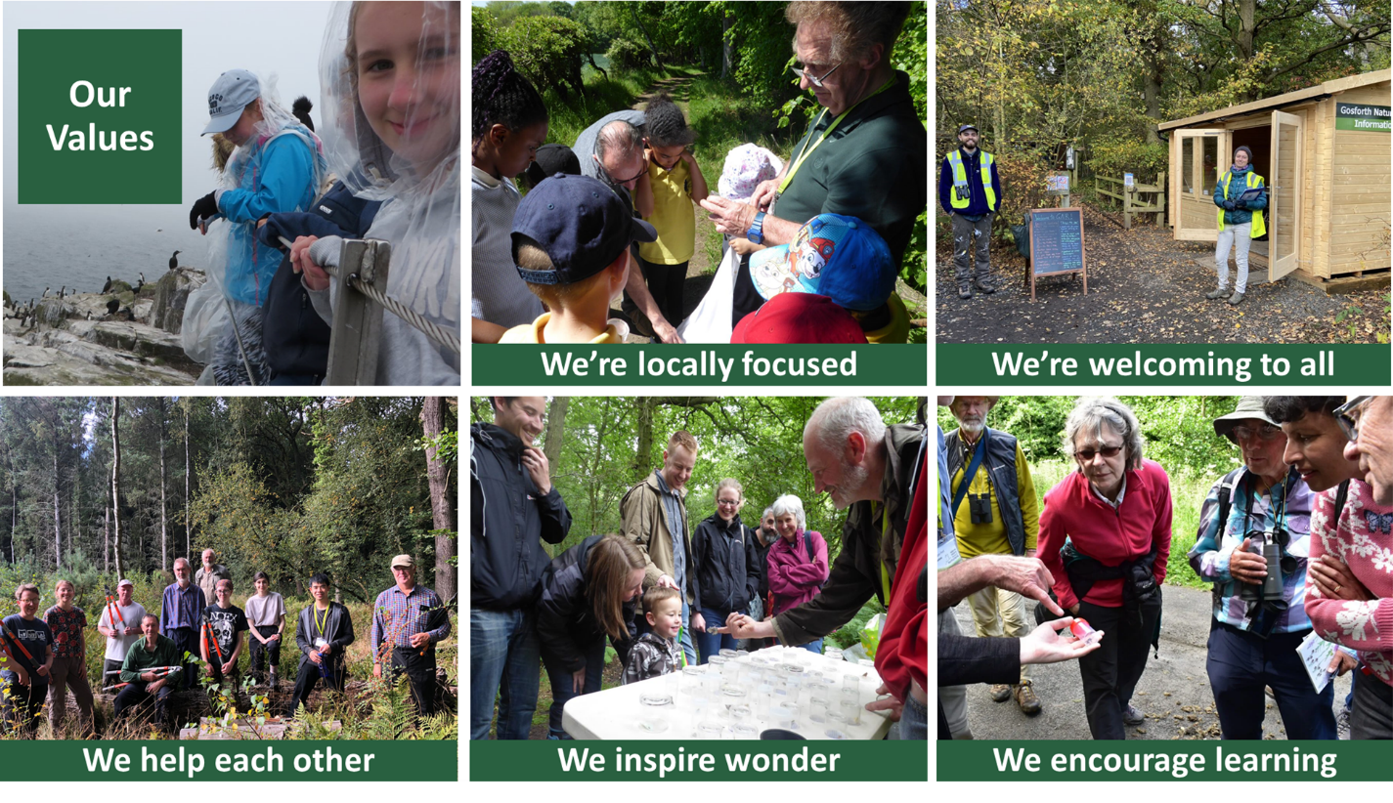
Student Testimonials

Alex Moore
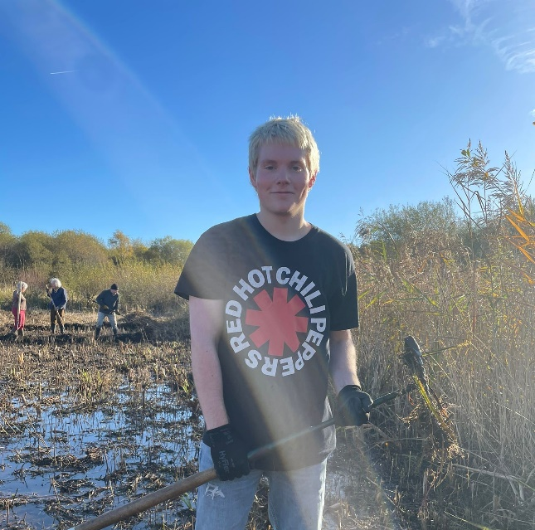
Newcastle University
Here at the NHSN, I have been given so many brilliant opportunities to push myself and develop new skills in a work-place environment that will be essential in my career aspirations moving forward. Not only does the placement heavily relate to my studies in zoology, but it has also given me the chance to branch out and test myself in other fields, such as engagement and communications, and practical skills such as construction and reserve management.
On a day-to-day basis you can find yourself working on a large variety of tasks, which really keeps each week stimulating and unique. From video editing to attending large conferences and events across the North East, I feel I have grown in confidence in my own abilities to change and adapt to new challenges and opportunities.
At the heart of the NHSN is an incredibly hardworking and welcoming network of staff and volunteers, that provides the perfect environment for anyone that is taking their first steps into working life. At all stages of my placement, I have felt supported and encouraged to try my best and push myself outside of my comfort zone to achieve new and exciting goals.
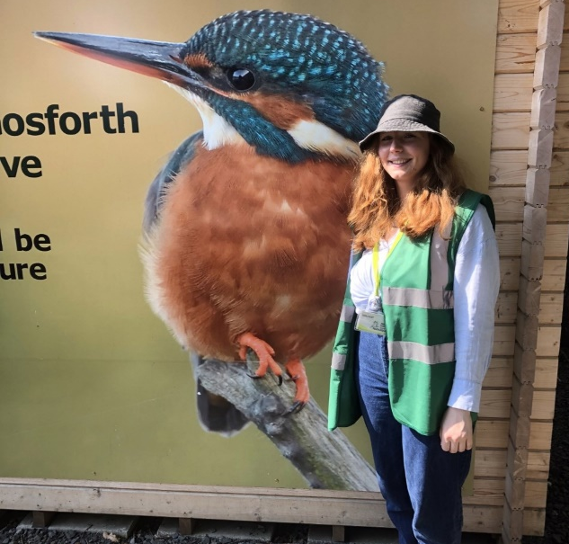
Amber Tatman
Northumberland College
My placement with NHSN has given me not only improvements to my professional development but also a grounding sense of purpose. With great encouragement and support from staff and volunteers, I’ve been given many opportunities to develop key transferable skills, such as project management, communication and engagement. I’ve found myself really thrive while working with NHSN and highly recommend this placement for students who are looking to follow a path in conservation and non-profit organisations.

NHSN Placements
Title | NHSN Placement Student (x2 posts)
Based at | Flexible working based in the NHSN Office, Great North Museum: Hancock, with some work at Gosforth Nature Reserve and home.
Placement type | Fixed term, full-time, 9-12 months, dates to be discussed at initial meeting
Reporting to | NHSN Senior Naturalist

Process for applications
- Please send cover letter supporting your application to james.common@newcastle.ac.uk setting out why you wish to undertake a placement with NHSN and what you feel you will bring to the Student Naturalist role (max 1-side of A4)
- Shortlisted candidates will be invited to a face-to-face meeting at Gosforth Nature Reserve or the Great North Museum: Hancock for an informal chat about the role.
About the role
As a small, regional charity, NHSN is home to a small staff team and much of our work is carried out by over 200 passionate volunteers across the North East.
Due to limited capacity, our work can vary greatly, and you will be required to assist with day-to-day tasks where needed.
An example of the tasks to be carried out during your placement can be found below. Others will be agreed with NHSN Director, Clare Freeman, and Senior Naturalist, James Common and your own ideas are welcome.
Key tasks
Nature communications
- To contribute content to NHSN’s social media channels, including wildlife sightings, updates from events, and new developments. E.g. student social media takeovers.

- To write regular blog posts for the NHSN website on your placement, exciting visits and other opportunities undertaken while with NHSN.

- Where necessary, to contribute to NHSN publications and provide updates for our weekly e-news.
- To assist with creating posters, leaflets and other resources as required.

- Assist with the labelling and filing of NHSN’s wildlife image library, researching the correct species where possible.
- To assist with filming and video editing as required

Conservation and practical work

- To join regular weekly conservation tasks managing habitats on site. E.g. woodland management, reed clearance and invasive plant removal.

- To undertake shadowing opportunities with naturalists at Gosforth Nature Reserve and elsewhere across the North East. Examples include butterfly and small mammal surveys.

- Contribute to day-to-day maintenance tasks such as keeping the Field Studies Room tidy, checking hides, and ensuring paths are clear of vegetation.

Public Engagement

- To assist with welcoming visitors at the reserve entrance and ensuring they are kept up to date with the latest news and wildlife sightings.

- To pilot acting as a ‘Pop up Ranger’ engaging visitors at certain points around the reserve about seasonal wildlife. E.g., butterflies in the meadow or birds in the hide.

- To attend NHSN walks and events, assisting event leads and capturing photographs for NHSN communications. If desired, create and lead your own events/walks connecting people with nature at Gosforth Nature Reserve.

- To lead a series of beginner-friendly guided walks exploring wildlife on site. The subject of these walks can be determined upon discussion with NHSN (Optional)

- To assist with activities at NHSN public open days and larger events. Examples include hosting a Welcome Stand to encourage NHSN membership or assisting with family-friendly activities.

- To act as Zoom support for NHSN Education Courses. E.g geology, ornithology. A fantastic opportunity to attend education courses for free.

- To support NHSN’s Monday night talks at Newcastle University (Oct-March), working with staff to ensure events run smoothly and members receive a warm welcome. You’ll also help with filming, field questions and encourage donations.

- To attend and support special, one-off events such as team away days hosted at Gosforth Nature Reserve.

- Trips to local nature reserves – acting as a spokesperson/representative for NHSN, communicating with local rangers and carrying out informal interviews for future blog posts.

- Selling of publications (journals, magazines), maps, nature activity bags, tote bags, badges, etc. Using the Zettle for contactless payment.

- Opportunities for public speaking - i.e. at the annual AGM

- Responding to members queries and requests when answering phone calls at the office

Wildlife and recording
- To accompany NHSN naturalists on regular wildlife surveys, including butterfly transects, BeeWalks, WeBS counts, and moth nights (seasonal)

- To carry out biological recording using NHSN’s iRecord activity, using own initiative to focus on under-recorded taxa at Gosforth Nature Reserve.

- To carry out and join surveys as part of NHSN’s three citizen science schemes, The North East Bee Hunt and North East Ladybird Spot (From February) and Discovering Orchids (from May).

- To explore opportunities to introduce regular surveys on a range of under-recorded taxa and/or introduce new ongoing contributions to national citizen science schemes.

- Students are welcome to attend a variety of NHSN events and education courses to supplement their placement (optional).

Other tasks
- To assist with any other tasks as required by the NHSN Director or Senior Naturalist
- To input ideas at NHSN
- Helping with NHSN’s regular members’ mailout
- Project support as part of ongoing NHSN projects

